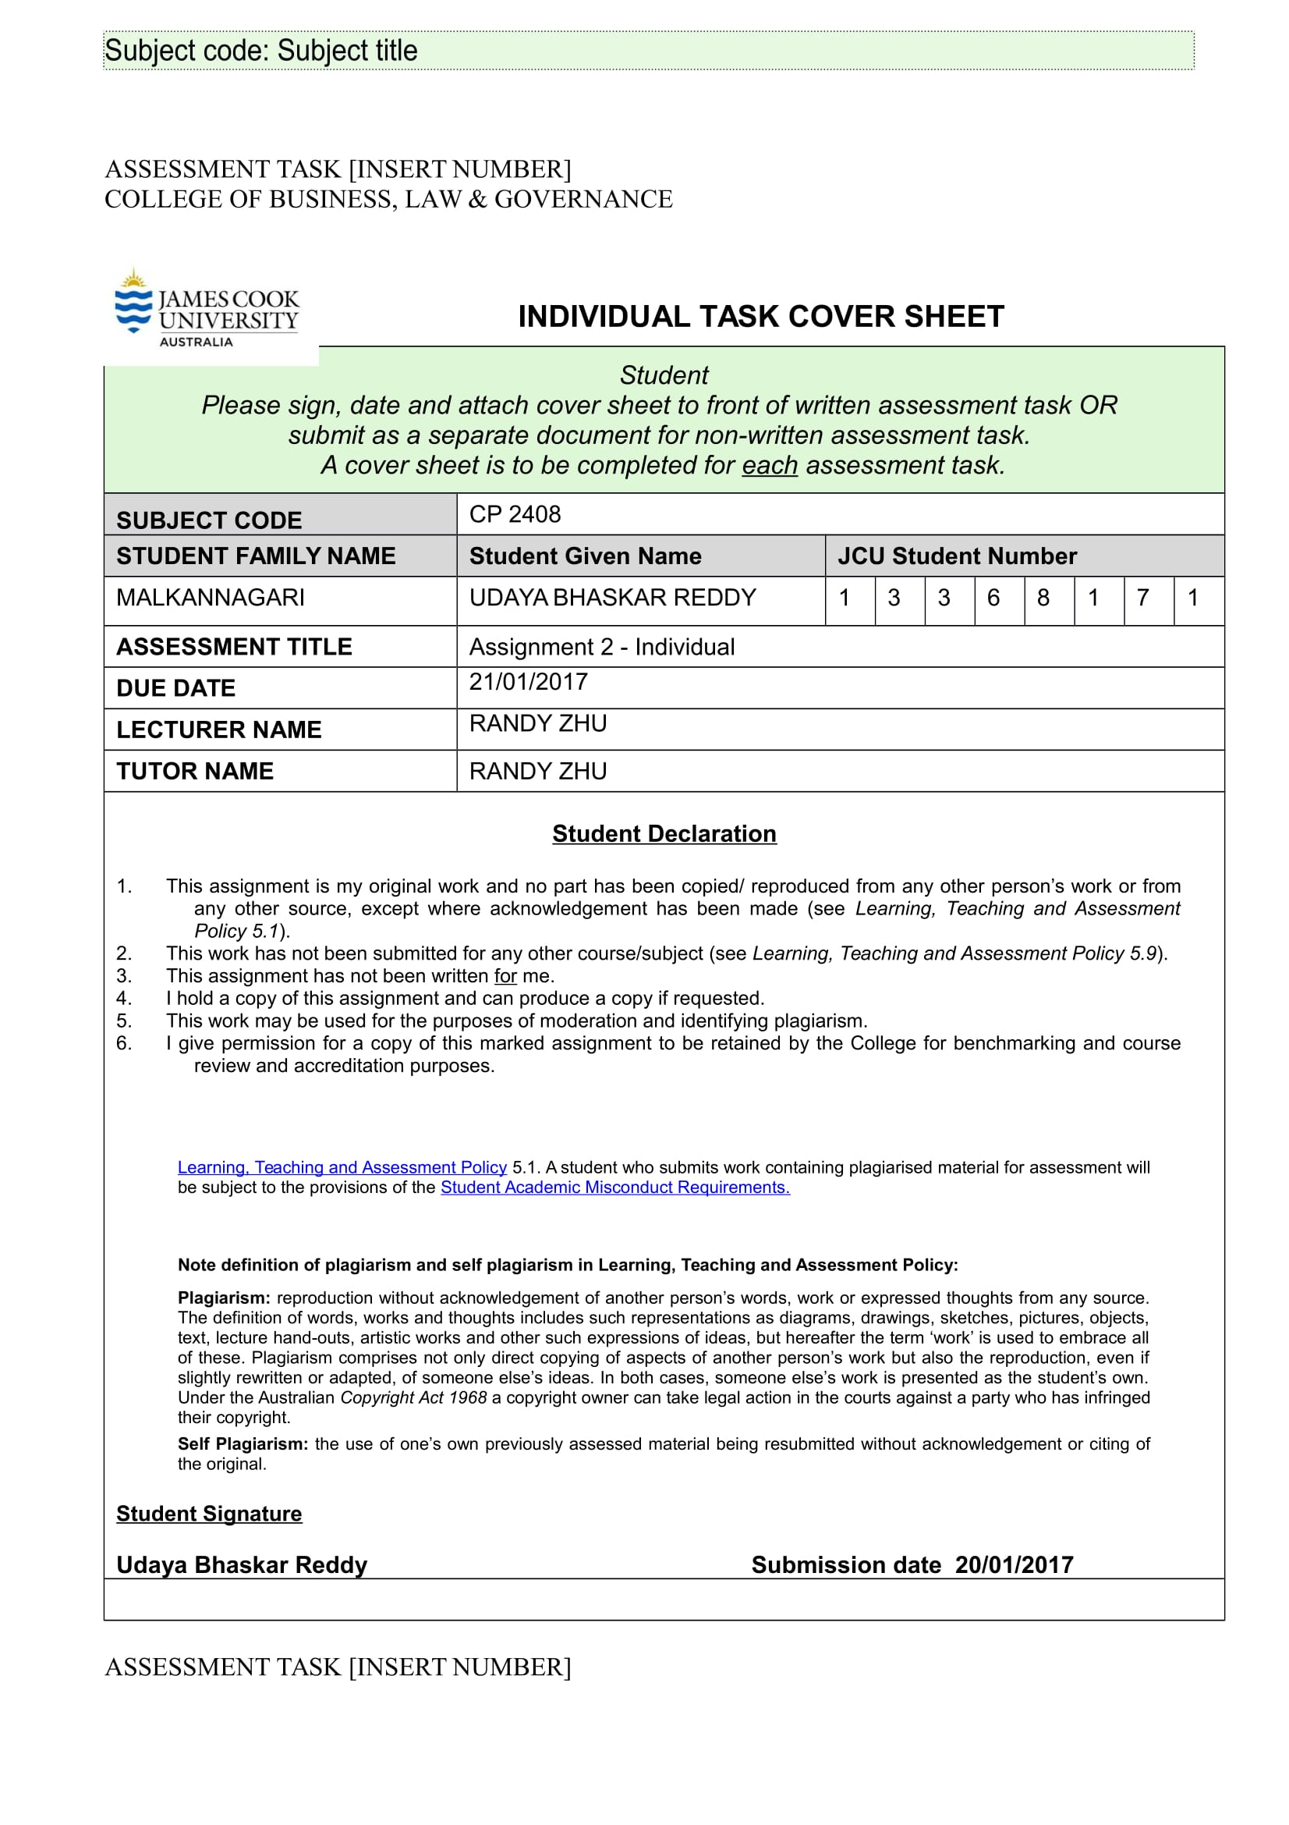

**Reflective Report:**

**Section 1:**

In this report, I will be describing my own role in helping the team achieve its goal during all the stages of our project work. This project has been an extensive exercise for my mind as it involved various levels of understanding of the core issues an immigrant faces during the initial phase of their ‘settling in’ process. Having had the experience of adapting myself to the conditions of a foreign country over a period of time, the biggest challenge for me was to correlate my own experience with that of an immigrant. The project has given me the opportunity to ‘live through’ the life of an immigrant during their initial ‘settling in’ process. The module ‘Design thinking’ has always been a psychological experience for me as it constantly enhances my understanding of the human nature behind the workings of a project.

Herein, I will provide my contributions to the workings of the group and how I facilitated in its overall functioning to achieve set goals. However, I would like to emphasize that this report is not a mere summary of the happenings of the project, it is more of a personal reflection of my thoughts and feelings during its entire course. I would like to elaborate on how each and every stage helped me gain a clarity of thought and a better understanding of what I was learning. I consider it an opportunity to gain self-knowledge by reliving through the experiences of my work.

In this cycle of the ‘Design thinking’ module, I have chosen to work in a group with familiar team members. I have had the experience of working with students from different nationalities during the last trimester. However, this time my experience is slightly different as all the group members are natives from my own country, India. Personally, it hasn’t affected my way of working within the confines of a group environment. But it helped me during the initial phase of working as it was easier for me to communicate and understand my team members which was not possible during the previous trimester. It was harder during the previous trimester as all of the team members shared different cultural backgrounds and I needed time to adjust and adapt myself to the functioning of the group. Having had such contrasting experiences in a short span of time, I believe that every group offers its own set of challenges irrespective of the nationality of the student participants and it is in our nature to adapt and help the team function as a single unit.

My team members include Sudheer, Spurgeon, Surya and Vihangi.

**Choosing the Challenge:**

For me, the biggest challenge was choosing the ‘Challenge’ itself. Out of the three challenges offered by the lecturer, the one that instantly caught my attention was the challenge based on the immigrants. I could relate with the challenge easily as I have had the experience of facing hurdles during the ‘settling in’ phase when I first came to Singapore to study. I could easily place myself in the immigrants’ shoes to understand the issues they face during that stage. The majority of the other group members were on the same line of thought as me and it was an easy decision for the team to choose the challenge.

**Contribution to the project map:**

After a few brainstorming sessions with the team, I was assigned the role of making the project map based on the inputs from all the team members. The challenge for me was to highlight the core issues an immigrant faces within the framework of a single end goal, that is helping the immigrant settle in. I have designed the project map in such a way that the connection between the stakeholders and the immigrants is clearly visible.

***My insights based on the project map:***

This experience is useful to me as a learner because I feel it helped me identify the key issues when dealing with a problem. I believe the project map is an easy to use interface to understand the problem and also the means to address it.

The project map and my contribution to it is referenced below in the minutes of the meeting.

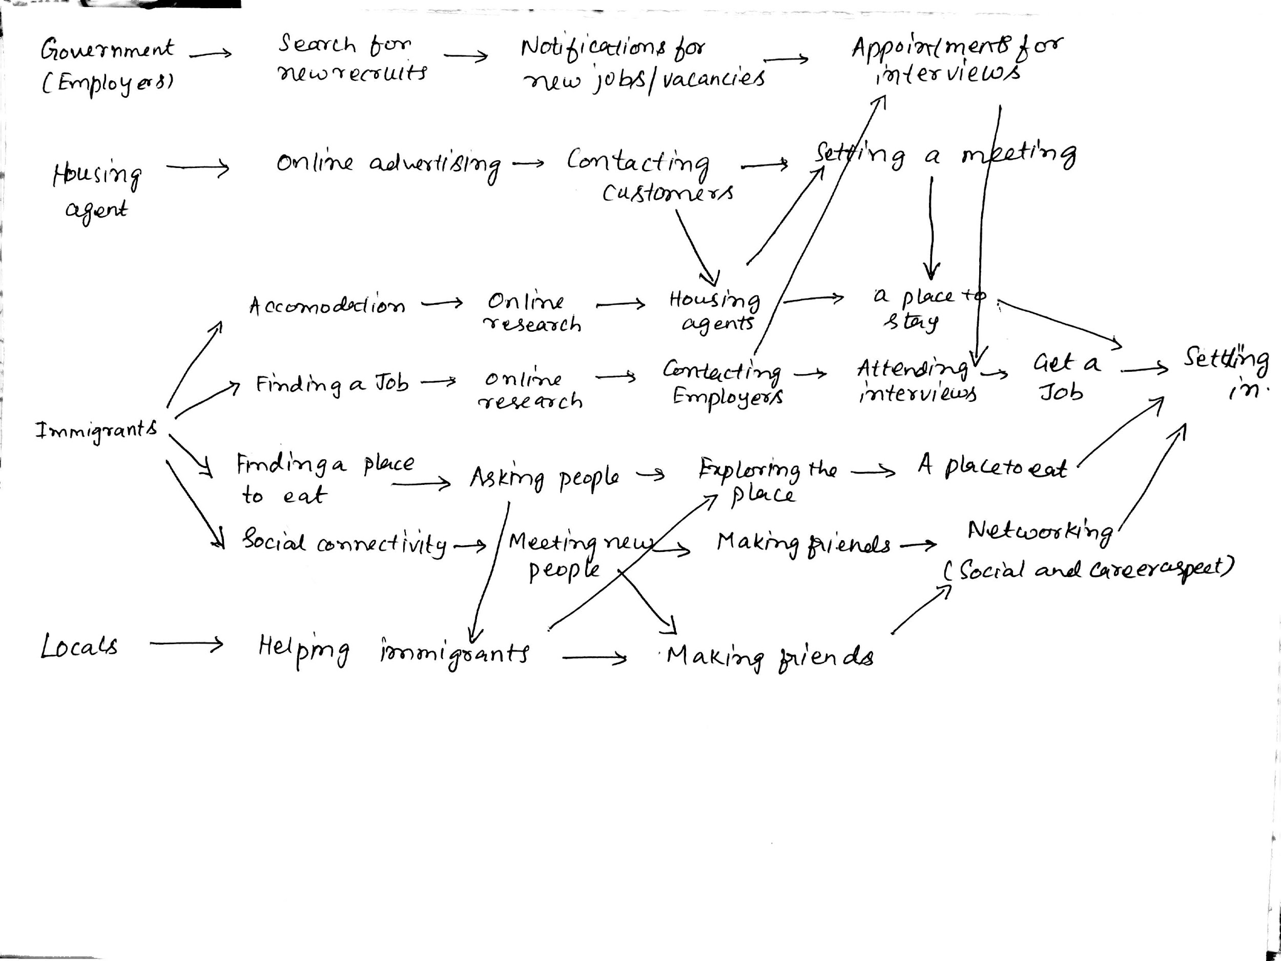

**Minutes of the meeting 2:**

Name of the Team : **RisingSun**

Date of meeting: 12th December 2016 6:00 pm to 7:30 pm

Members present: All team members

Members absent: None

Meeting chairperson: Sudheer

Minutes taken by: Uday

Summary of meeting: (what has been discussed, decisions made)

The meeting started with a discussion and brainstorming session. We formed the long-term goal. We then listed down the questions that using the long term goal. We even interviewed a few international asking them their opinion about what problems can the immigrants face when settling in Singapore. We made a board with sticky notes. The sticky notes contained answers to each of these questions we received from the interview. Using these answers, we decided to create a draft project map indicating 4 major issues the immigrant might face while settling in.

Action items for Team members:

|  |  |  |
| --- | --- | --- |
| Actions to Do | Who will do this work? | By when? |
| Form the final project map | Uday | Next meeting |
| Research about the problems the immigrants will face during settling | All team member | Next meeting |
|  |  |  |

Next meeting date and time: 15th December 2016 2:00 pm to 5:00 pm

**Storyboard sketching:**

For me, Storyboard sketching was one of the most interesting parts of the whole exercise. The primary reason for that is it gave me the opportunity to look at things from different perspectives. To define a statement within the paradigm of an idea is always a difficult task. I was assigned the role to write the script for a story based on the housing app we are making for the immigrants. The challenge was to highlight the key issues and create a constant flow to the whole story. The interviews I conducted gave me a proper understanding of the issues that need to be taken into consideration. But the challenge was to identify these issues based on well researched feedback from the user. For example, our app has a feature to filter fake agents which the entire group thought would be beneficial to the user. However, the interview feedback showed contrasting opinions. When I interviewed a person from India, the feature was of paramount importance to him as he faced similar problems in his home country. But further research on the topic revealed that it is not much of an issue in Singapore as agent registration is mandatory. In this case, the user feedback was not well researched and the issue doesn’t hold much importance in the context of Singapore as it does in his home country.

***My insights based on Storyboard sketching:***

This experience with Storyboard sketching gave me a chance to understand the relevance of an issue within a certain context.

***Interview Transcripts:***

Each member of the group conducted interviews based on the assumptions we made. The interview I conducted revealed some interesting facts. The user identified himself with the key issues that the team put forth. The user had a lot of knowledge and experience in the usage of smart phones. The user’s preferences for a house was mostly in line with the assumptions we made, like finding a house near his workplace or MRT, or near their ethnic community. The user also talked about the accessibility of the housing agents in Singapore during the course of conversation. All in all, I felt the interview was satisfactory and most of the assumptions we made were fulfilling to the task at hand.

**Prototype Iterations:**

Prototype iterations has been the most crucial part in this whole exercise. Our work is based upon a lot of research and understanding of the needs of the user. The initial phase of the prototype is based on the assumptions the team made in identifying the core elements that need to be incorporated in the MVP. The latter phases involved user testing and feedback which was essential in giving the shape to a final design that caters to the interests of an immigrant. My contributions during these phases of project development is explained in detail below.

**TEAM Leader:**

I worked as the Team leader for this group. My individual contributions are explained below.

**Contributions to Iteration 1:**

I was assigned the role of a ‘Designer’ during this phase of the project. Our first prototype is a paper drawing and I was given the task of making multiple paper sketches for user testing. I researched online and analysed the basic designs of various housing apps. I studied the design layouts of all the popular apps that are available in the market. The challenge for me was to incorporate a user-friendly design that highlights the key issues the team identified when we came out with the features. The whole idea of our app was to identify and fill in the existing gap for an immigrant-specific application and my task was to highlight these design choices in a simple yet effective manner.

**Page Design Insights:**

1. I suggested the design for the ‘Welcome’ page to be simple so that it allows the user to input their ‘user name’ and ‘password’. It also highlights the language options in the application with a dropdown menu.
2. When designing the ‘Home’ page, I chose to create a layout that shows a hierarchy in the list of available features. The most important features of our app, Properties, Near me, Search by Interest and Find an agent, are listed in box format for the user to identify easily.
3. I made the ‘Search by Interest’ page with all the nearby locations mentioned in the dropdown menu so that the user can easily browse their choice of interest.
4. I incorporated a map format while designing the ‘Near me’ page with a list of all nearby hotspots in the footer so that user can easily choose the hotspot they want near their house.
5. The ‘Find an agent’ page includes a keyword input feature to select an agent. I also added a horizontal scrolling at the bottom of the page to make the user identify the agents by their speciality (HDB, Condo, etc.,)
6. I made the ‘Contact Us’ page with a simple layout that displays basic information.

Furthermore, as the leader of the group, I had the extra responsibility of co-ordinating the functions of the individual team members. I played a supportive role to another group member ‘Sudheer’ by giving him valuable suggestions while making the paper model of the MVP. He was a willing partner during this phase of the project. I also had the added task of organising team meetings to gather inputs from all the team members at every stage of design. I had to oversee the work done by another group member ‘Vihangi’ on the storyboard sketching. Initially the group thought of making colour-paper drawings for the story, but in the end I suggested we stick with the digital story format as it was an easy to use tool.

Storyboard reference: [www.storyboardthat.com](http://www.storyboardthat.com)

**User Testing:**

I conducted user test for this iteration by showing the prototype to the user and asking them to use it. The results are summarised below.

***What did the user value the most?***

The user was impressed with so many features included in the prototype. The user felt that features like the ‘language’ translator and having the option to search for properties near their ethnic community locations was of paramount importance to him.

***What got them excited?***

The ‘Search by Interest’ page got this user most excited. He said it will be extremely beneficial to him in finding a home near his own ethnic community and MRTs.

***What would convince them about the idea?***

The idea to have an immigrant-specific mobile app that helps the user find a home near their own ethnic community seemed like a plausible idea to this user. He felt it was a feature he always looks out for but never found in similar housing apps.

**Images:**

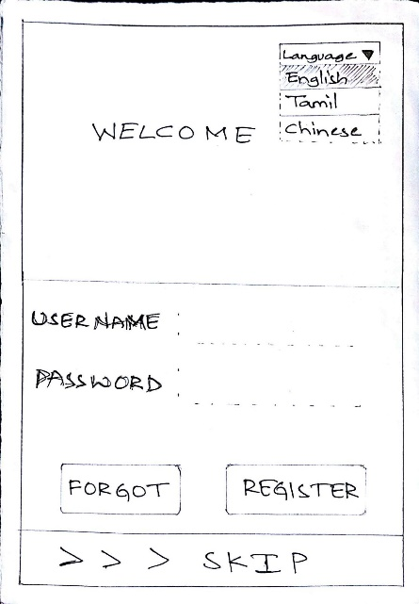 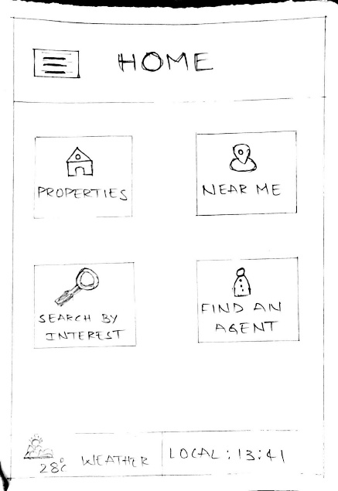 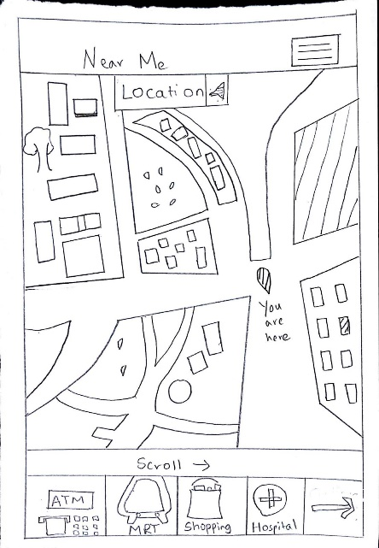

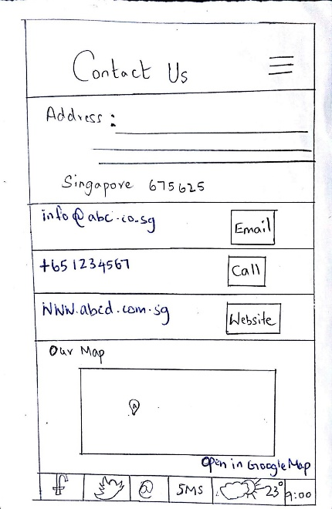 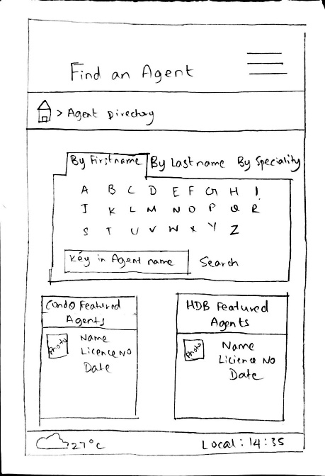 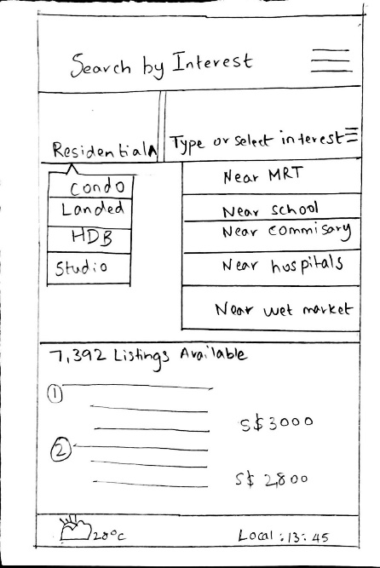

**Contributions to Iteration 2:**

As the work progressed, I had an enriching feeling of actually making a product that might work as a replacement to the current existing products in the market. The user feedback for the first iteration was crucial in designing the second iteration. But before going into the actual design, I would like to elaborate on the team decision we made with regard to the second iteration. Since the third iteration has to be a high-fidelity version, I suggested the team used a digital version for the second prototype, albeit a low-fidelity one. I believed that a transformation from low-fidelity to high-fidelity can be much more visible when we use digital versions for both the iterations. The team also agreed with my opinion and we decided to create a digital version for this iteration.

***Designing the digital version:***

During this phase as well, I was assigned the task to work on the digital version along with my team member ‘Sudheer’. I used the ‘Balsamiq’ software to create the digital prototypes. The software was easy to use and helped me finish the project quickly. Initially when I looked at this software, I was surprised at how easy it was to use for a beginner like me. I didn’t have to spend much time on understanding it, it had a simple layout of buttons that can be drag n dropped to make the project. I felt we can include some of the features in its design in our app to make it look user-friendly.

While designing the prototype I took care of wire framing the entire pages. Since this is a low-fidelity version I felt the text has to be visibly clear for the user to understand the features, and there must be a consistent hierarchy in displaying the information on the page. I used a basic color theme for designing the pages as I believed a more refined color-scheme can be used in the next iteration.

**User testing:**

I conducted the user testing for this iteration. The results are summarized briefly below.

***What did the user value the most?***

The user was extremely impressed with the digital version of the prototype. He said the basic design layout was impressive and all the important features have been highlighted properly. The transformation from paper to digital seemed like a convincing idea to them, and the user was able to identify different aspects of the pages in a much more efficient manner now.

***What got them excited?***

The feature ‘Search by Interest’ got the best feedback from the user.

***What would convince them about the idea?***

The idea to have an immigrant-specific app with language translator and agent ratings seemed plausible to the user. The user felt allowing direct chat options with the agents is beneficial to them as they don’t usually find it in the existing apps.

***Page Designs:***

The page designs were similar for some of the pages like ‘welcome’ and ‘registration’, however some pages were altered. I stuck with the same design choice for the ‘Home’ page, but the content was edited. The ‘Near me’ feature was removed as it was already incorporated in the ‘Search by interest’. The ‘Near me’ feature will now be a pop up from one of the property pages. I edited the ‘Find an agent’ page, and added a feature ‘chat with agent’ with the inputs from all the team members. This page also lists the ratings for an agent. The ‘weather updates’ page was removed as many users felt it was not essential for the app.

***Insights:***

Upon refining the design choices based on user-inputs, I realized that a user wants a ‘call to action’ to be highlighted (in this case, ’Chat with agent’ and ‘Search by Interest’) and the digital prototype is an effective way to accomplish this task. This experience also helped in realizing the ease and effectiveness of using digital softwares(Balsamiq) while working on such projects.

**Digital Prototype reference:** [www.balsamiq.com](http://www.balsamiq.com)

**Images:**

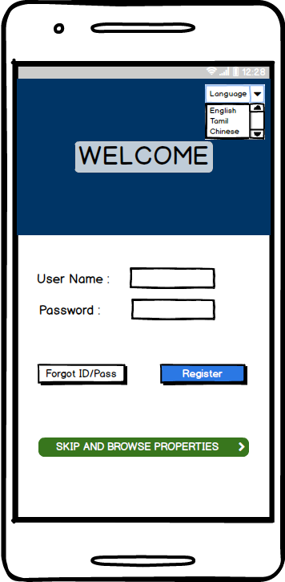 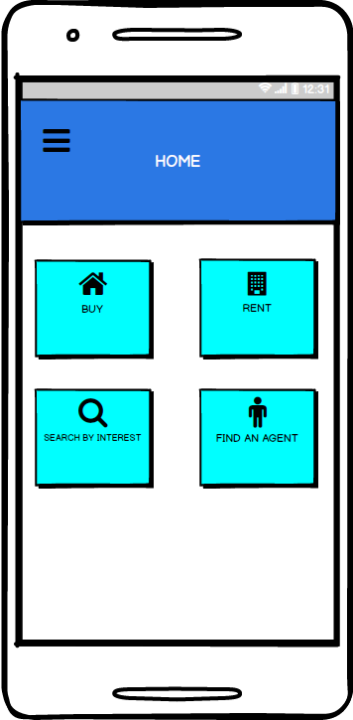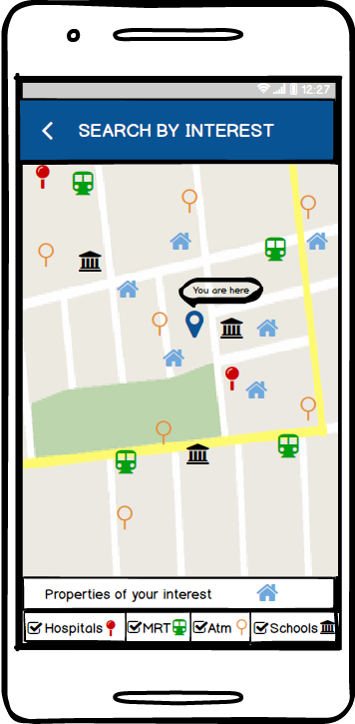

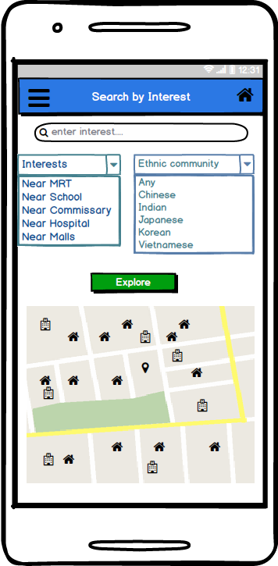 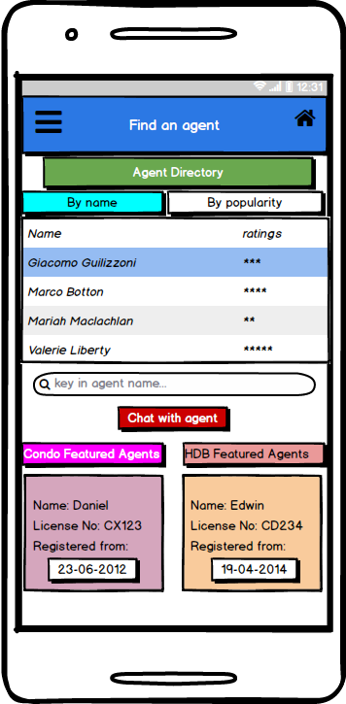 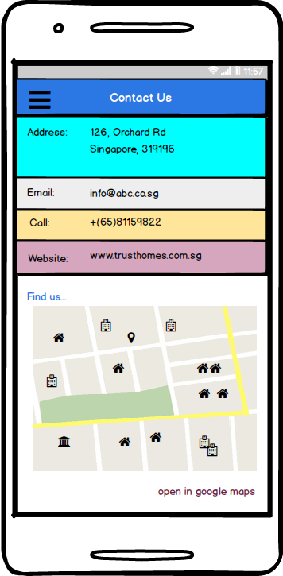

**Contributions to iteration 3:**

The designing of this version of the prototype was assigned to another group member, ‘Surya’ and I had to play a supporting role in assisting him with his work. Since I worked on the previous two iterations, it was an easy task for me to guide my friend along set paths of this design process. This version of the prototype has its focus of user interactivity and visual appeal. I suggested a combined login page for both the individual and agent as it removes redundancy and improves accessibility. The group approved my idea and it was incorporated into the final version of the prototype. The major change in this iteration was the ‘listings’ feature that was incorporated in the home page. This feature allows the user to look at new listings available and increases the efficiency of the app in general by filtering the old listings and updating the user with new properties. This provides an effective way of enhancing user-satisfaction which was evident in my user testing.

**User Testing:**

I conducted the user testing for this iteration and the results are summarized below.

***What did the user value the most?***

The user valued the ‘listings’ feature more in this version of the prototype. He said this feature is an added advantage for longtime users as it saves a lot of time in browsing through the whole property database.

***What got them excited?***

The visual design of the app got them excited the most. They felt the color-theme was perfect.

***What would convince them about the idea?***

The idea to have an immigrant specific mobile app with an option to search for ethnic community locations while finding a house sounded plausible to the user. His favorite feature from the beginning has been the ‘Search by interest’ page.

**Images:**

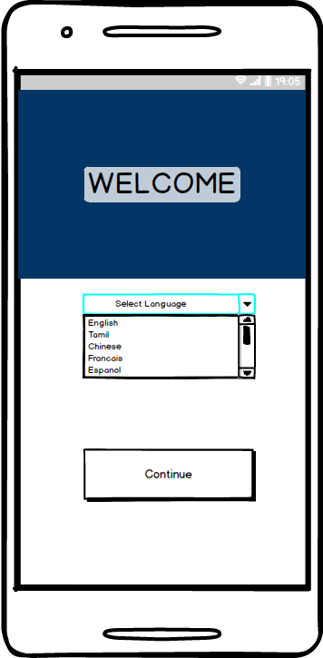 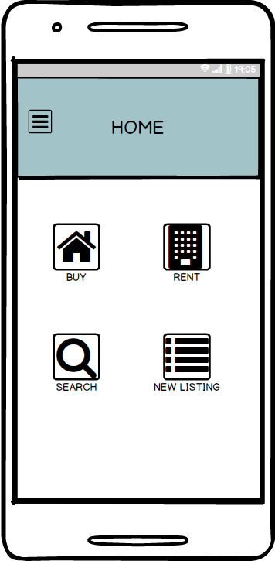

**Section 2:**

***My learning experience in moving from one Iteration to the next:***

Herein, I will summarize my learning experience in moving from one stage of prototyping to the next. My views are based on personal observations in working with the design and interacting with the users while conducting usability testing. Iterations, I believe, are a way to refine our product according to the user’s requirements. To give importance to the necessities of the user and to implement it within the context of the design at the same time is a challenging process.

**First Iteration – paper drawings**

The three stages of prototyping have their own significance in the whole design thinking process. The first iteration of our project was paper drawings that replicate the design of a mobile app. The paper drawings were helpful as it was easy to make and adjust to the user sensibilities. They were just used as a tool to validate the value of our concept. The feedback from the user was mostly about the features incorporated within the application. The design choices were not significant during this stage as the user was mostly observant about the features. Since paper sketches can be redrawn multiple number of times it was an effective way to explore the viability of the various aspects of design and change them accordingly.

During the user testing, I have observed the user being drawn to the features offered in our app. The visual design of our app was not of primary importance to them. They were mainly concerned about the functionality and the relevance of features during this iteration. The feedback from the user were general opinions based on their likes and dislikes with regard to the features implemented.

**Customer Feedback:**

***Testing:***

The user testing gave me this feedback. The user was unable to go back to the ‘Home’ page because of the lack of buttons in some pages. The user was unable to differentiate between several options in the ‘Near me’ page because of the lack of visual cues. When accessing the ‘Find an agent’ page, the user questioned about the agent choice he has to make when dealing with multiple agents. Furthermore, the user was unable to understand a few design choices like horizontal bars indicating price range and type of house.

***Insights and Changes:***

1)Based on the user testing, a few navigation issues were to sorted in the next iteration.

2)As the user was unable to distinguish between the options in the ‘Near me’ page, separate icons need to be used in the second prototype with different colors to distinguish them.

3)As the user wanted to make an agent choice, ratings need to be added to the agents based on user reviews so that the user can gauge the expertise and user friendliness of the agents when trying to find a house.

4)As one of the users talked about communicating with the agent directly, a chat tool needs to be incorporated within the app.

This testing helped me gain an initial hold of the key issues the user was looking at. The user had prior experience of using online apps before. However, the testing revealed that some of the key elements he wanted were missing. This user was mostly drawn to unique features like ‘Searching a house near an ethnic community’ which shows that including specific features can make our app a viable option for the immigrants.

**Second Iteration – Low Fidelity Prototype**

The main change for the second iteration was its transformation from a paper prototype to a digital version. It was an upgraded product when we compare it to the previous stage. As a comparative study, I can say this iteration had equal importance to both the features as well as the visual design of the app, wherein the first iteration was mostly about the features. The user was able to assess the information hierarchy and layout of the whole page. Even the navigation and some basic design choices like the displaying of text in an inconsistent format was assessed by the user. Overall, I believe it was a transformation phase in implementing the actual design choices for user-friendliness of the app.

***Changes incorporated in the digital version:***

The changes made for this version are mostly visual design choices. I would like to highlight some design choices for this iteration. The ‘Near me’ page was incorporated as a feature in the ‘Search by interest’ page as it explains a common theme. ‘Near me’ page is removed as a feature from the ‘Home’ page and instead extends the ‘Search by interest’ page with a color-coded map. The ‘Find an agent’ page included ratings for the agents as per the user testing done in the previous iteration. Some other design choices improved the basic navigation and flow of the app from one page to the next. I believe, the use of a digital version for this iteration was extremely beneficial in incorporating all the necessary changes.

**Customer feedback:**

**Testing:**

I conducted user testing for this iteration. The user was impressed with the overall design of the app. The digital version excited him. He said it was easy to navigate and understand the features better with the visual cues. Some inputs from the user were significant for the next iteration. The user said that since he already tested the app once, can he find new listings instead of going through the whole menu of options again. This input marked a new feature to the overall usability of the app. The user expressed satisfaction with the ‘Find an agent’ page and said the chatting tool was incorporated nicely. However, the user was unable to understand some design choices like empty text bars while navigating through the property page.

***Insights and Changes for the next iteration:***

1)Based on the user testing, the empty text area in some pages needs to be changed to combo boxes or sliding bars to display information according to the data used (price range, house type etc.,)

2)A new listings feature needs to be added in order for the user to have access to new house listings. Since the app has registered users, it shortens redundancy and allows the user to have quick access upon multiple usage of the app.

3)Some missing features like sorting the properties based on price or neighborhood need to be made more user-friendly. The second iteration had the property page for sort but the user was unable to understand its relevance suggesting a new design choice for this option.

In a broader picture, the second iteration was mostly a transition phase. It’s a mix between the designing the app and implementing the required. Both parameters were of equal importance during this stage. Upon testing the user, I understood that visual design plays a key role in attracting the consumer.

**Third Iteration – High Fidelity Prototype:**

The third iteration of our project had a high-fidelity version of the prototype. This, I believe, is the next step in enhancing consumer usability. The user was now able to interact with the app with navigation features incorporated with the help of online tools(www.marvelapp.com). The visual design has been significantly enhanced. For me, the main difference between this iteration and the previous is the overall visual appeal and interactivity of the whole design. There was a clear transformation from the paper sketches to the final design now. In the first iteration where paper drawings were used, the usability was tested mainly on the basis of features and partly about the actual design of the app. But when it came to this stage, the whole process reversed. The features were more or less fixed, albeit some minor additions, and the overall usability was based on the visual theme and interactivity of the app. I observed a clear change with regard to this transformation.

***Changes incorporated in the High-Fidelity Version:***

The new property listings feature was added in the main page. There were some enhancements when it came to the visual design of the app. The user interactivity was included by using online tools to simulate a working version by making clickable pages.

**Customer feedback:**

During the user testing I conducted, the user was extremely impressed with the final design of the prototype. The interactive feature we used to make it clickable was the most appreciated feature during this stage. The feedback from user made me realize the value of user-interactivity and visual design when making a project work. The user was also drawn to the call to action immediately as it was properly highlighted with the aid of colors and fonts. The listings feature was well appreciated.

**Section 3:**

**Personality Tests:**

Reference: <https://www.16personalities.com/free-personality-test>

The team used a personality test to identify the strengths of each team member. In order for the team to function as a cohesive unit, each member must collaborate and channelize their efforts toward a collective goal. Assigning tasks to individual members is a crucial phase in making a project successful. Every individual has a unique set of talents that can be utilized within the framework of a group to make its function more effective. I believe the test we took gave us a better understanding of our individual skills and we allocated our roles accordingly.

**Test result**:

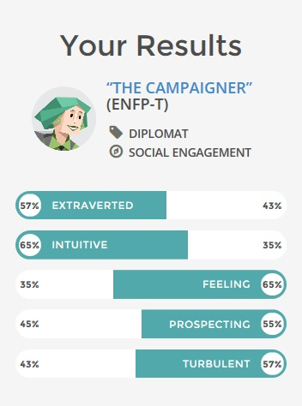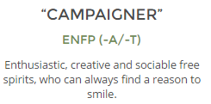

My personality test reflected exactly the kind of person I am. I am a sociable and free minded person who dwells on having good rapport with each and every individual I come across. I am intuitive and extroverted which the group felt as an ideal attribute choice for a team leader. My biggest strength is to smile in the times of adversity and keep the spirits high. I can collaborate easily with all the other members and organize their work tasks in an effective manner.

In the initial phase of the project I organized team meetings and allocated individual roles to different group members. My role was to channelize the ideas of individual team members toward an end goal. I allocated tasks to each member based on their natural talents. For example, my team member ‘Sudheer’ is an avid user of mobile applications. His personality test also revealed that he can provide constant support when working within the framework of a group. He falls under the ‘Mediator’ category. Such people have an aptitude to come with sensible ideas and act as a supportive system to the entire group. I identified this talent and allowed him to take charge when it came to some critical design choices during the making of our app. I believe a leader must incorporate and allow the team to function based on the strengths of its members, it’s a way of ‘passing the baton’ from one person to the next.

During the third iteration of the prototype I played a supportive role to allow my other group member ‘Surya’ make some critical design choices for the app. I provided inputs and constant feedback to all the group members whenever they needed me. I was also a medium of communication between the group and our lecturer. I updated our lecturer with the progress of our project and seeked his guidance to make sure we were on the right track.

**Collaboration with the team:**

The best thing about collaborating with this team was the timely manner in which everything happened. As mentioned before, I had a prior experience of working in a different group during my first trimester. I had experiences of members underperforming which left me with no choice but do all the hard work individually. However, this time the work was split equally among all the group members and it made achieving the task much more easy. However, there were some discrepancies I need to mention. There were some inconsistencies when it came to finishing the tasks. Some team members were confusing the Lean UX model of Design thinking with our previous trimester module and were losing track of their set goals. I had to spend time with each and every team member, individually, explaining the minor differences they need to understand during the whole process.

Another important aspect of our team collaboration that I liked most is sharing of knowledge and information. We used tools like whatsapp, Dropbox as our constant communication channels. Each team member updated their work on a periodic basis and asked for inputs from the other team members. I felt it was essential step in making a good project and it was one of the best aspects of working with this team.

**What might I do better when collaborating in future?**

There are certain things, I believe, I can change when collaborating with a team in future. I would like to adjust more to the sensibilities of my team members. Sharing knowledge and information is of paramount importance, but allowing the freedom for the members is equally significant in creating a proper output. My interference or rather support in every aspect of our design is evident. However, I realized that sometimes it is better to allow the member have the freedom to finish their tasks based on their own ideas. There are occasions I felt my support was interfering with their way of functioning and I unknowingly super imposed some of my ideas into their design choices. I will try to rectify that aspect of my nature when I collaborate with a team in future.

If I were given a chance to change my role for the next round, I would like to play the role of a ‘Mediator’. I believe my extroverted nature will be useful to co-ordinate the functioning of the group. The reason why our team functioned as a cohesive unit this trimester is mainly because of members with strong ‘Mediator’ attributes (Me, Sudheer, Spurgeon). Whenever there was a conflict of issues, the mediators in our group would interfere and resolve it through dialogue. This, I feel, is the secret of success of any group work.

**Section 4:**

**Pros and Cons of the Lean UX process:**

After starting to implement the lean UX methods in the design of our project, I realized it was not a clear on/off switch. Rather it was more of a gradual shift in my thinking and midset about the value of user insights in our product development.

***Advantages:***

The main advantage of this process, I believe, is we can get the learnings much faster when we compare it to the more traditional methods. This was evident when we chose to user test the MVPs. Our team split this task between two groups of members and we were able to get our results quickly. However, results doesn’t mean good results always. For example, as mentioned before the customer feedback on fake agents wasn’t entirely accurate in the context of Singapore and that in turn left me on a longer road of validating it further. Despite some inconsistencies, I felt it was a systematic way of reaching the end result. The transformation from paper drawings to the interactive version of the final prototype was laid out in a step by step manner.

Another big advantage is it unites different members of the team under a common goal. In our case, each member were essentially assigned different tasks. Vihangi was involved in story boarding, Spurgeon was involved in documentation, me and other group members were involved in designing prototypes. However, each one of us were eager to study the user testing results as we had the same goal of validating the hypothesis.

***Disadvantages:***

The main disadvantage that I see in this whole process we cannot guarantee anything to the upper management. We can guarantee some kind of learnings by the end of a certain time-boxed period, but we can’t truly say that the product will be ready to launch at app store by then because we don’t know if it will work or not. This was evident in my collaboration with the group during the testing phase. My group member ‘Surya’ was unable to finish his task because the user feedback was inconsistent and he needed further advice from the team. Validating the hypothesis lead to an increased time pressure on the part of the participant.

Another disadvantage relates to the scale of the project we are working on. There is a chance that to arrive at what is valuable for the customer we may need to overproduce and throw stuff away. This was evident for the first iteration. Our team had to make a lot of drawings to finally arrive at the end product for our first iteration. I would like to infer that setting the project on the right track can be a troublesome when its scale is much larger and involves high costs.

Overall, I believe that the lean UX is a problem focused method wherein the validation of ideas and removing waste make a crucial role in delivering the final output of the project.

**What situations do I think each process is best suited for?**

The main advantage of lean UX is it saves time and resources through constant iterations and review. This was observed while conducting user testing for the three iterations. Our team was able to finish the user testing in just a single day for each iteration. Since our app was for the smart phone, all the users we tested were well aware of its basic usage and were eager to participate and give their suggestions. This situation made me realize the efficiency of lean UX methods in the current scenario. And we were able to achieve our end goals in quick time.

**How might lean UX influence your software development practices in the future in terms of outcomes like producing quality software?**

The lean UX methods used while working on this project made me realize the significance of a proper working method when dealing with different situations. In our case, the lean UX was the most effective method because it had every one of us involved as a team in all the stages of development. And the scale of our project is much smaller. The methods we used to get user feedback was also time saving as we used paper prototypes for the first iteration. Changes were made quickly and drawings were altered. However, this method may not be effective when it comes to working on a bigger project like making a desktop software for an organization. Such kind of a project will need more expertise and organizational structure. In this case, the waterfall model will be a viable alternative.

In Conclusion, I would like to say that this work has been an exercise of mind that helped me learn and understand the value of team spirit in making a successful product. The methods we used were also helpful in understanding the value of user feedback when designing a project. I also realized the importance of analyzing the situation and choosing the right methods to effectively implement the design process. I will use this experience in my future endeavours as well.

**Minutes of the meeting:**

|  |  |  |
| --- | --- | --- |
| Topic | Plan | Objectives (<50 words) |
| Storyboard | Date :29th December 2016 Time: 3:00 pm to 6:00 pm  Venue : Student Hub | To create a story board indicating the problems the user may face |
| Sketching, Interview | Date :2nd January 2017 Time: 6:00 pm to 7:30 pm  Venue : Student Hub | Making the storyboard , and deciding features for the application |
| Interviews, Iteration 1 | Date :5th January 2017 Time :2:00 pm to 5:00 pm  Venue : Student Hub | Conducting interviews and preparing prototype 1 |
| User Testing, Iteration 2 | Date : 9th January 2017 Time :12:00 pm to 2:30 pm  Venue : Student Hub | Performing user testing and making prototype 2 |
| User Testing , Final Iteration mvp | Date :12th January 2017 Time : 5:00 pm to 7:00 pm  Venue : Student Hub | Performing user testing and making prototype 3 |

**Meeting 1:**

Name of Team:   
Date of meeting: 29th December 2016 3:00 pm to 6:00 pm   
Members present: All team members  
Members absent: None  
Meeting chairperson: Uday  
Minutes taken by: Surya  
Summary of meeting:

We gathered and discussed the comments given for assignment 1. We than changed the outcomes and then decided to create a story board. We discussed the ideas which could be used to make the story board. We concluded the meeting with deciding to make rough sketches for the story board.

Action items for Team members:

|  |  |  |
| --- | --- | --- |
| Actions to Do | Who will do this work? | By when? |
| Create a google document | Vihangi | Same day |
| Research on the topic | All team members | Next meeting |
| Rough sketches | All team members | Next meeting |

Next meeting date and time: 2nd January 2017 6:00 pm to 7:30 pm

**Meeting 2:**

Name of the Team :

Date of meeting: 2nd January 2017 6:00 pm to 7:30 pm   
Members present: All team members   
Members absent: None  
Meeting chairperson: Sudheer  
Minutes taken by: Uday  
Summary of meeting: (what has been discussed, decisions made)

The meeting started with all the team members showing their rough sketches. The rough sketches were than discussed. We than combined the rough sketches and made a rough sketch. The final sketch was to made by the next meeting. We also discussed the kind of interview questions we must ask. Upon listing down all the questions, we chose the 12 questions which would be the most suitable. The meeting concluded with noting the interview questions.

Action items for Team members:

|  |  |  |
| --- | --- | --- |
| Actions to Do | Who will do this work? | By when? |
| Making the final storyboard | Vihangi | Next meeting |
| Conducting interviews- 2 each | All team member | Next meeting |
| Scripting | Uday | Next meeting |

Next meeting date and time: 5th January 2017 2:00 pm to 5:00 pm

**Meeting 3:**

Name of the team :

Date of meeting: 5th January 2017 2:00 pm to 5:00 pm   
Members present: All team members  
Members absent: None  
Meeting chairperson: Vihangi   
Minutes taken by: Spurgeon  
Summary of meeting: (what has been discussed, decisions made)

The meeting started with each of discussing the results of the interviews. On analysing the interview questions we understood the need of the users, through which we listed down a number of features. Through these features, we made rough sketches of the first prototype.

Action items for Team members:

|  |  |  |
| --- | --- | --- |
| Actions to Do | Who will do this work? | By when? |
| Prototype 1 | All team members | Next Meeting |
| Perform user testing – 2 each | All team members | Next Meeting |
|  |  |  |

Next meeting date and time: 9th January 2017 12:00 pm to 2:30 pm

**Meeting 4:**

Name of Team:  
Date of meeting: 9th January 2017 12:00 pm to 2:30 pm  
Members present: All team members  
Members absent: None  
Meeting chairperson: Surya  
Minutes taken by: Vihangi  
Summary of meeting:

The meeting started with discussing the feedback which we got from prototype 1. Than we made rough sketches for iteration 2. Upon creating these images , we decided to perform the user testing.

Action items for Team members:

|  |  |  |
| --- | --- | --- |
| Actions to Do | Who will do this work? | By when? |
| Prototype 2 | Sudheer, Uday | Next meeting |
| User Testing – 2 each | All team members | Next meeting |
|  |  |  |

Next meeting date and time: 12th January 2016 5:00 pm to 7:00 pm

**Meeting 5:**

Name of Team:  
Date of meeting: 12th January 2017 5:00 pm to 7:00 pm  
Members present: All team members  
Members absent: None  
Meeting chairperson: Spurgeon  
Minutes taken by: Sudheer  
Summary of meeting:

The meeting started with discussing the results of iteration 2. The feedbacks seemed to be positive. Only a minor changes were required, in terms of design. We created the images and incorporated it using the marvelapp software and concluded the meeting. We than proceeded to complete the individual assignment.

Action items for Team members:

|  |  |  |
| --- | --- | --- |
| Actions to Do | Who will do this work? | By when? |
| Prototype 3 | Surya, sudheer | 19th January 2017 |
| Complete the assignment 1 | All team members | 19th January 2017 |
|  |  |  |

Next meeting date and time: --

***Some images and experiences while working on this project:***

